**Problem 2: Read the instructions carefully and answer accordingly. If there is any need to insert some data then do that as well.**

**a. Suppose you have a file named "data.txt" containing important information. Display the first 10 lines of this file to quickly glance at its contents using a command.**

Answer:-

to implement this first i have created a directory called info using mkdir info command then i have created a empty file in info directory using touch data.txt and written some names in it and saved it and to display 1st 10 line i have used head -10 data.txt command

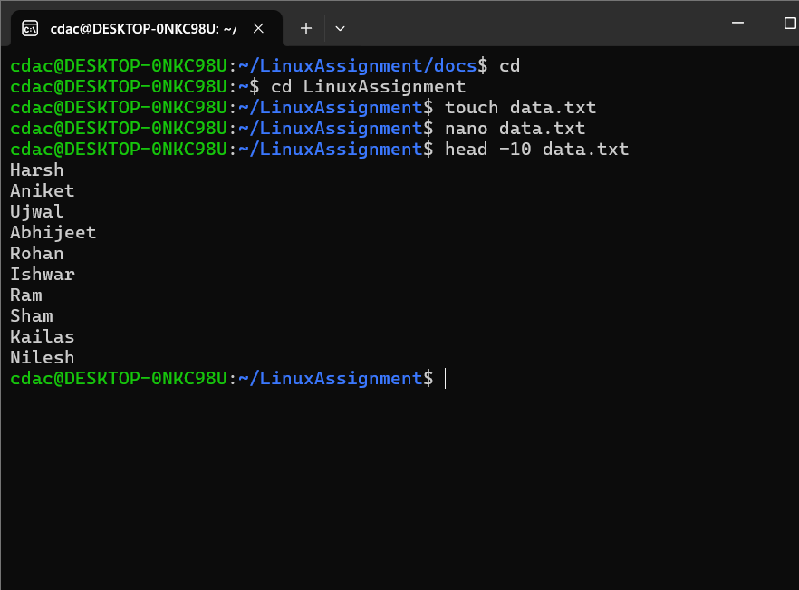

**b. Now, to check the end of the file for any recent additions, display the last 5 lines of "data.txt" using another command.**

Answer:-

to implement this first i have created a directory called info using mkdir info command then i have created a empty file in info directory using touch data.txt and written some names in it and saved it and to display last 5 line i have used tail -n 5 data.txt command

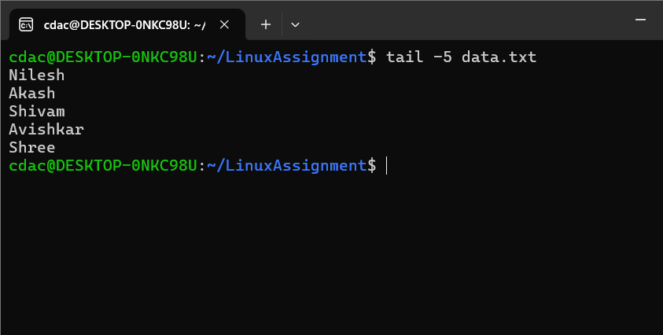

**c. In a file named "numbers.txt," there are a series of numbers. Display the first 15 lines of this file to analyze the initial data set.**

Answer:-

to implement this first i have created a directory called info using mkdir info command then i have created a empty file in info directory using touch numbers.txt and written numbers from 1 to 20 in it and saved it and to display first 15 line i have used head -15 numbers.txt command

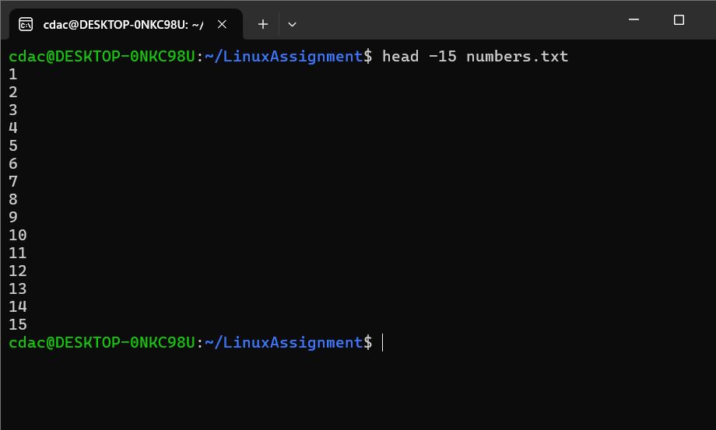

**d. To focus on the last few numbers of the dataset, display the last 3 lines of "numbers.txt".**

Answer:-

to implement this first i have created a directory called info using mkdir info command then i have created a empty file in info directory using touch numbers.txt and written numbers from 1 to 20 in it and saved it and to display last 3 line i have used tail -3 numbers.txt command

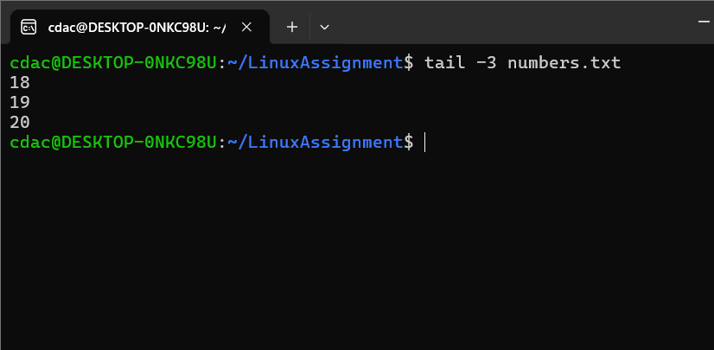

**e. Imagine you have a file named "input.txt" with text content. Use a command to translate all lowercase letters to uppercase in "input.txt" and save the modified text in a new file named "output.txt."**

Answer:-

I have create input.txt file and then opne it into editor using nano input.txt and written some small letter words in it and then using this command i have changed the small letters into capital once tr 'a-z' 'A-Z' < input.txt > output.txt

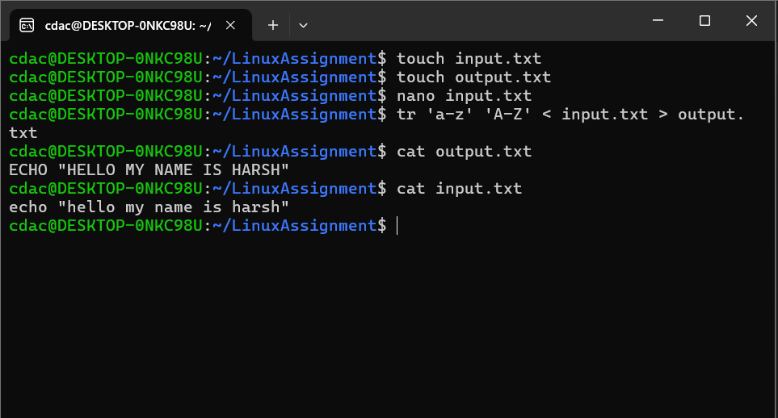

**f. In a file named "duplicate.txt," there are several lines of text, some of which are duplicates. Use a command to display only the unique lines from "duplicate.txt."**

Answer:-

First i have create duplicate.txt file using touch duplicate.txt the opened the editor using nano duplicate.txt and to remove duplicate i have used sort duplicate.txt | uniq this command so that all the duplicate texts got removed.

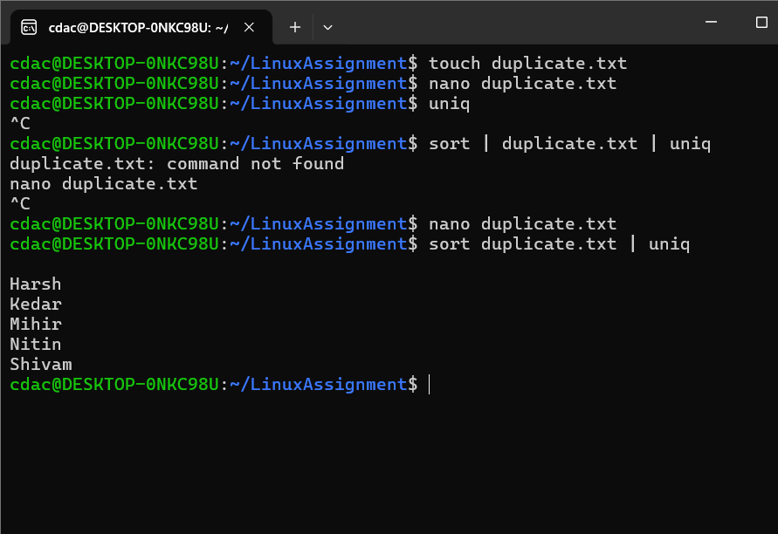

**g. In a file named "fruit.txt," there is a list of fruits, but some fruits are repeated. Use a command to display each unique fruit along with the count of its occurrences in "fruit.txt."**

Answer:-

First i have created a file using touch frouts.txt then added some frouts in it and then for sorting i have used sort fruit.txt | uniq -c command for how much the count of frouts are there and to arrange it by sequence i,e sorting by number of times they occur i have used command called sort fruit.txt | uniq -c | sort -nr

